A

Report

On

Freshers welcome 2022

Department of PHILOSOPHY

Rabindra Mahavidyalaya, champadanga,hooghly

Session: 2022-23

Theme: Freshers welcome

Venue: Rabindra Mahavidyalaya, champadanga,
room no. 71

Date: 20th August,2022

Organizer: Department of Philosophy

Objectives:

- Helping them adapt to the new environment

- Building students’ confidence

- To foster cordial relationship with students’

- To introduce about course, examination structure, evaluation system etc.

- Dealing with critical and argumentative situations

summary

An Freshers welcome is organized by the Department of Philosophy on 20th August 2022.On that day, wall magazine was inaugurated before freshers welcome. The n the reception of the freshers started through the cultural program. Current students welcomed the freshers with flowers and drops of sandalwood. Freshers are introducing to current students. Students are encouraged to uphold the tradition, dignity of this institution. The event ends with various cultural programs of dance, song, recitation.

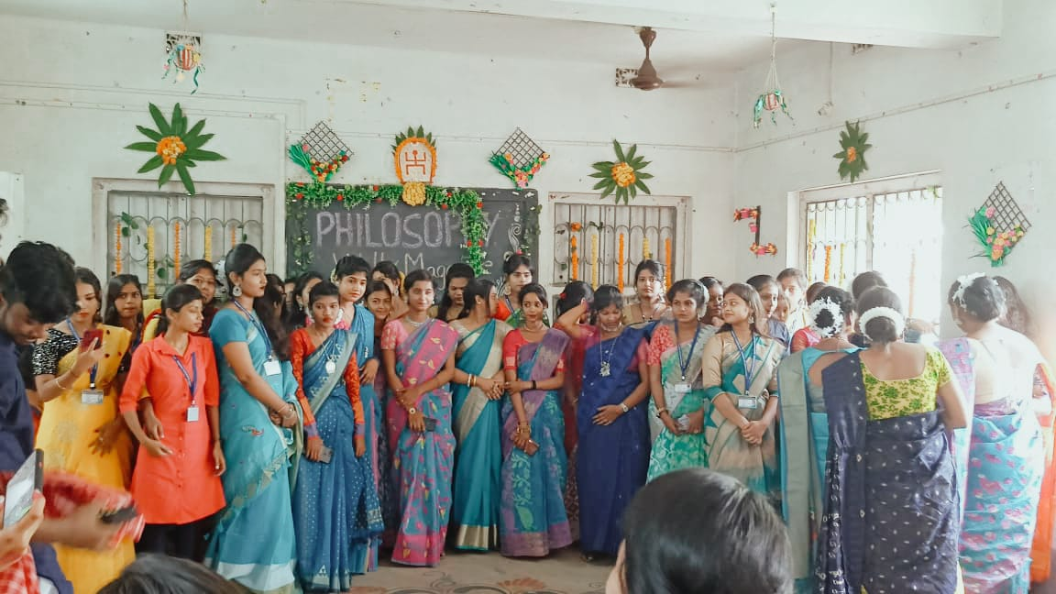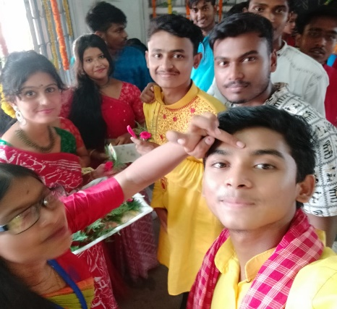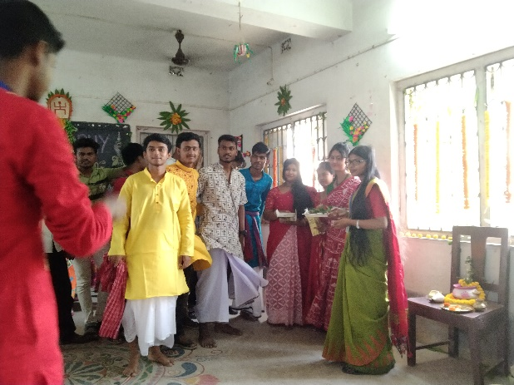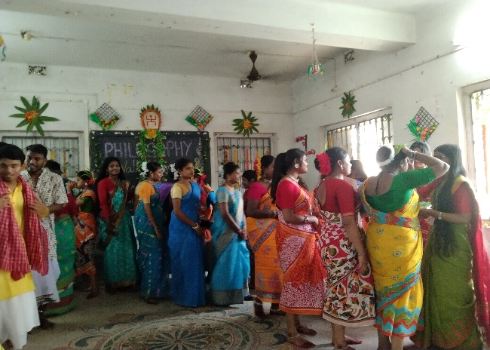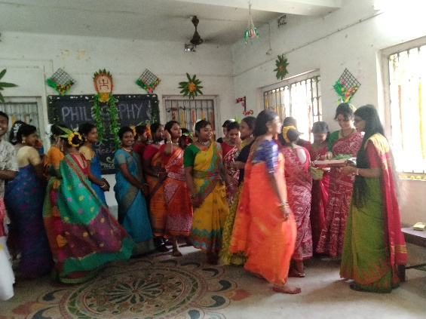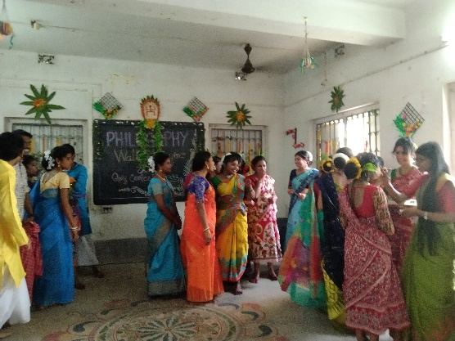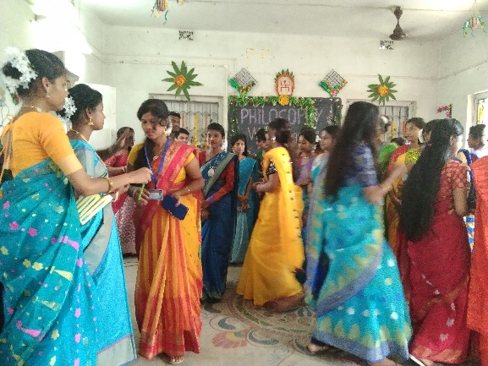
The freshers are welcome by present students

Our perticipent: 70 students
Male:20
Female: 50

Tentative programme schedule
- Inaugural session: 12 noon to 12.30 p.m.
- Freshers welcome:12:30p.m. to 1.00p.m.
- Lunch break: 1.00 p.m. to 1:30 p.m.
- Cultural programme: 1:30 p.m. to 4:30 p.m.

